Paradox 4.0 performance project

Requirements
After a couple of consecutive runs, Paradox 4.0 slows down the machine and it needs to be restarted. It is required to find a solution;

Plan of actions
- Try and replicate the problem – I will try to install Paradox 4.0 myself and run a couple of queries;
- Identify whether the problem is with Paradox itself or DosBox configuration;
- Run Paradox on virtual machine and take the performance stats: most probably machine becomes slow due to huge Physical or kernel memory usage;

Open questions
- Please send as many details as you can about the machine configuration where Paradox 4.0 runs (RAM size, CPU, Operation system, etc.);
- For preliminary analysis, please send a screenshot of the Performance Stats at the time when computer becomes slow, as example:
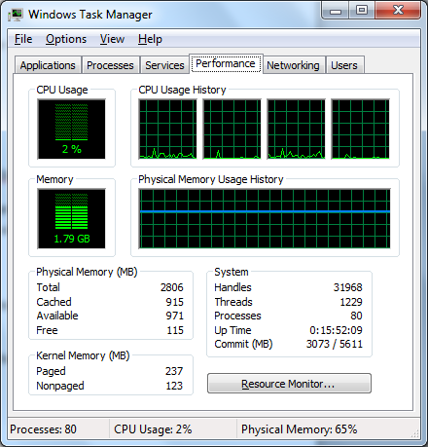

Future enhancements
Is applicable in your case the upgrading to a more modern database?

